Defence against infection
The body is constantly defending against attacks from pathogens. The first line of defence against infection stops the pathogens from entering your body. These first lines are general defences, and are not specific to fight against certain types of pathogen. We call this non-specific, and they can be physical or chemical barriers.

Physical barriers against infection

Skin
The skin covers almost all parts of your body to prevent infection from pathogens. If it is cut or grazed it immediately begins to heal itself, often by forming a scab, which prevents infection as the skin acts as a physical barrier. Parts of the body that do not have skin have developed other ways to prevent infection. For example, the eyes produce tears which contain enzymes. These enzymes are chemical barriers.

Nose
The nose has internal hairs, which act as a physical barrier to infection. Cells in the nose produce mucus. This traps pathogens before they can enter the lungs. When the nose is blown, mucus is removed and any pathogens are trapped within it.

Mucus and ciliated cells
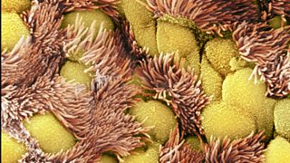
The trachea runs from the nose towards the lungs. The cells that line the trachea also have hairs called cilia, which are much smaller than those in the nose. These are called ciliated cells. The ciliated cells waft their hairs in a motion like a Mexican wave at a football match and move mucus and pathogens upwards towards the throat where it is swallowed into your stomach. Other cells called goblet cells create the mucus in order to trap pathogens. The production of mucus in your airways is a physical barrier.

Ciliated cells in the airways waft away dust and pathogens trapped in mucus

Chemical barriers against infection

Stomach acid
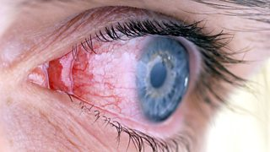
The hydrochloric acid in our stomachs does not break down food. It is part of the body's non-specific first line of defence. It is hydrochloric acid and while it does us no harm, it is strong enough to kill any pathogens that have been caught in mucus in the airways or consumed in food or water. Stomach acid is a chemical barrier against infection.

Lysozymes To stop eye infections we have evolved chemicals within our tears called lysozymes. These are enzymes that destroy bacterial cells by breaking down their cell walls. Lysozymes are found in saliva, breast milk and mucus, as well as in tears. Lysozymes are chemicals so, like stomach acid, they are a form of chemical defence against infection. Conjunctivitis can occur if pathogens are not killed by lysozymes

The immune system defends against disease
You can catch a communicable disease when you are exposed to a pathogen. There are many ways in which this can happen, but some include touching an infected person, drinking dirty water or breathing in an airborne pathogen.
If pathogens pass the non-specific first line of defence they will cause an infection. However, the body has a second line of defence to stop or minimise this infection. This is called the immune system. As a part of this there are two types of white blood cell called phagocytes and lymphocytes.

Phagocytes
Phagocytes are white blood cells. They are attracted to pathogens. They surround them in the blood, bind to them and engulf them.
The phagocytes' membrane surrounds the pathogen and the enzymes found inside the cell, then break down the pathogen in order to destroy it. As phagocytes do this to all pathogens that they encounter, we call them 'non-specific'.

Lymphocytes
Lymphocytes are another type of white blood cell. They recognise proteins on the surface of pathogens called antigens. Lymphocytes detect that both the proteins and pathogens are foreign, not naturally occurring within your body and produce antibodies. This can take a few days, during which time you may feel ill. The antibodies created by the lymphocytes cause pathogens to stick together, and make it easier for phagocytes to engulf them.
A specific type of lymphocyte called a memory lymphocyte can 'remember' the antigens from an infection by a previous pathogen. A second exposure to it will result in a much faster immune response. Antibodies will be produced much faster, which often stops us becoming ill again. There are hundreds of common colds caused by different viruses. It is very unlikely you will become infected by the same virus because memory lymphocytes exist to fight the infection immediately. This response to a known antigen is called the secondary response and it is much quicker than the response to an antigen for the first time.
During the primary infection the antibodies slowly increase, peak at around ten days and then gradually decrease. A second exposure to the same pathogen causes the white blood cells to respond quickly in order to produce lots of the relevant antibodies, which prevents infection.
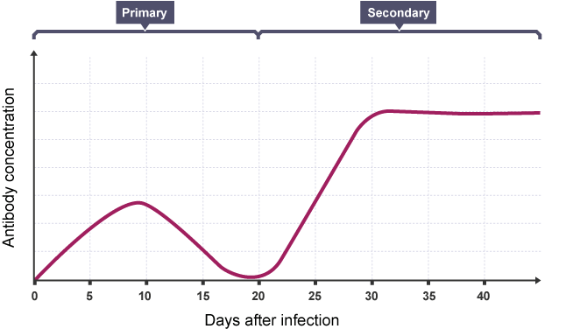
Some pathogens produce toxins which make you feel ill. Lymphocytes can also produce antitoxins to neutralise these toxins. Both the antibodies and antitoxins are highly specific to the antigen on the pathogen, thus the lymphocytes that produce them are called 'specific'.

